Workshop 3 .1 Turing Machine and decidable
Yura Hernandez Hernandez

- Given the language:

$L = \{w | w ∈ \sum{}*,\sum{}=\{a,b\}, w does not contain the substring aba\}$
- Construct a Turing Machine that accepts L.

- 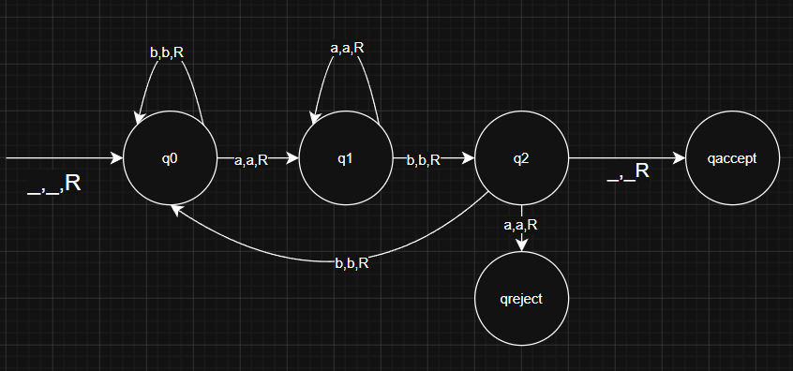

- Trace the execution for the input bababb

state | input - cursor (bold one) | decisión
q0 | bababb
q0 | ababb
q1 | babb
q2 | abb
qreject | bb | the substring aba is in the string REJECTED

- Show that L is decidable

- yes, because it only goes right til the input end or the substring aba is in the string.

2) Given the language $L = \{ww | w∈\{a,b\}^{+}\}$

- Design a Turing machine that accepts L
- Describe how the designed ™ works
- Trace the execution for the input abab
- Trace the execution for the input bab

3) Design a turing machine with no more than 5 states that accepts the language (01 + 011)*

- 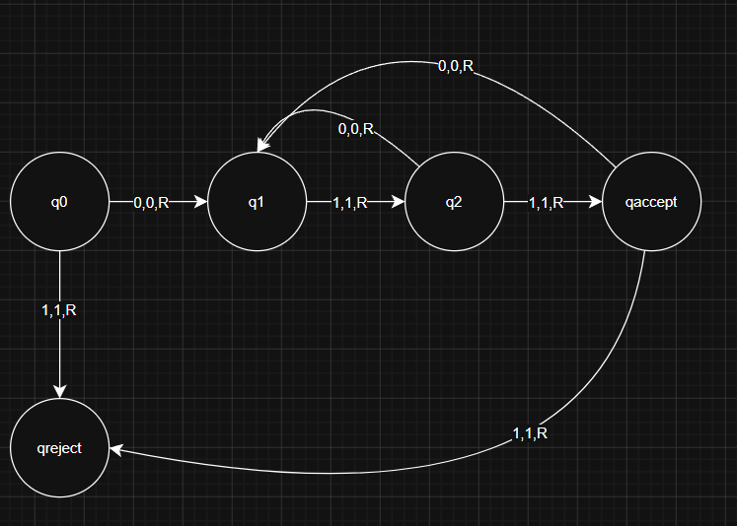

4) Given the language $L = \{ w ∈ \{a,b\}* | \#a(w) ≤2\#b(w) \}$

- Design a turing machine that accepts L

- 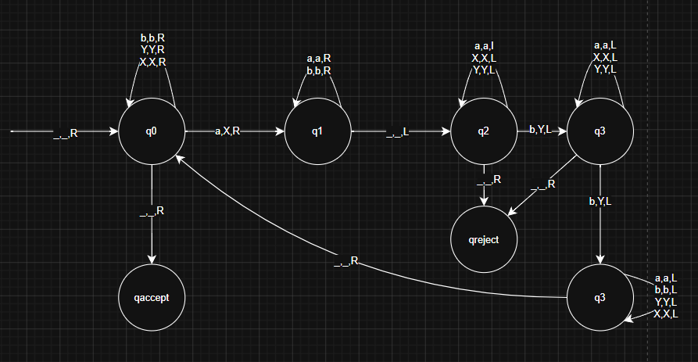

- Is L decidable? justify your answer

yes, because always have an answer for this, or the string ends, or encounters an extra a so always is going to stop.

5) Design a turing machine that adds one to a given binary number. The input binary number is written on the tape, surrounded by blank symbols. The machine must halt in an accept state with the incremented binary number left on the tape.

- 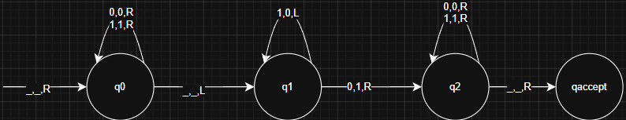

6) The turing machine showed in the next figure recognizes the language $L = \{0^{2^{n}}|n ≥ 0\}$
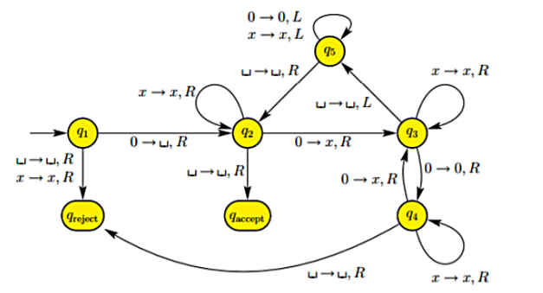

- Analyze how the machine processes the strings:

- 0000000

state | input - cursor (bold one) | decisión
q1 | 0000000
q2 | _000000
q3 | _x00000
q4 | _x00000
q3 | _x0x000
q4 | _x0x000
q3 | _x0x0x0
q4 | _x0x0x0_
qreject | _x0x0x0__ | rejected

- 000000

State | Input - cursor (bold one) | Decisión
q1 | 000000
q2 | _00000
q3 | _x0000
q4 | _x0000
q3 | _x0x00
q4 | _x0x00
q3 | _x0x0x_
q5 | _x0x0x  _x0x0x  _x0x0x  _x0x0x  _x0x0x  _x0x0x
q2 | _x0x0x  _x0x0x
q3 | _xxx0x  _xxx0x
q4 | _xxx0x  _xxx0x_
qreject | _xxx0x__ | rejected

- 00000

State | Input - Cursor (bold one) | Decisión
q1 | 00000
q2 | _0000
q3 | _x000
q4 | _x000
q3 | _x0x0
q4 | _x0x0_
qreject | _x0x0__

7) Given the language $L = \{ w\#x | w is a substring of x \}$

I don't know the alphabet.

- design a turing machine that accepts L
- Describe how the designed ™ woks

8) Given the language $L = \{ x + y + z | x,y,z are binary integers and x+y=z \}$

- Design a Turing machine that accepts L
- Describe how the designed ™ works

